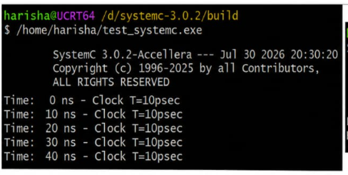#include <systemc.h>

SC_MODULE(rtos_scheduler)
{
void task1()
{
while(true)
{
cout << "Task1 Running at "
<< sc_time_stamp() << endl;

wait(1, SC_SEC);
}
}

void task2()
{
while(true)
{
cout << "Task2 Running at "
<< sc_time_stamp() << endl;

wait(1, SC_SEC);
}
}

SC_CTOR(rtos_scheduler)
{
SC_THREAD(task1);
SC_THREAD(task2);
}
};

int sc_main(int argc, char* argv[])
{
rtos_scheduler obj("Scheduler");

sc_start(6, SC_SEC);

return 0;
}

